Report template

Measurement practice I.

Team members:
Miklós Csizmadia (ABC123), Tamás Horváth (EFG456)

1. About the measurement
In this section, the measurement should be described in text (what you measured). What was the goal of the measurement.

1.2 Equipments
List here the instruments used in the measurement. The pictures attached in the measurement instructions do not need to be inserted!!
- digital multimeter
- measurement wire
- resistor table

2. Measurement results
This chapter contains the measurement results. It may contain text (description, comment), equations, pictures, simulations (circuit or results) tables, etc.
Here are examples of each of these.

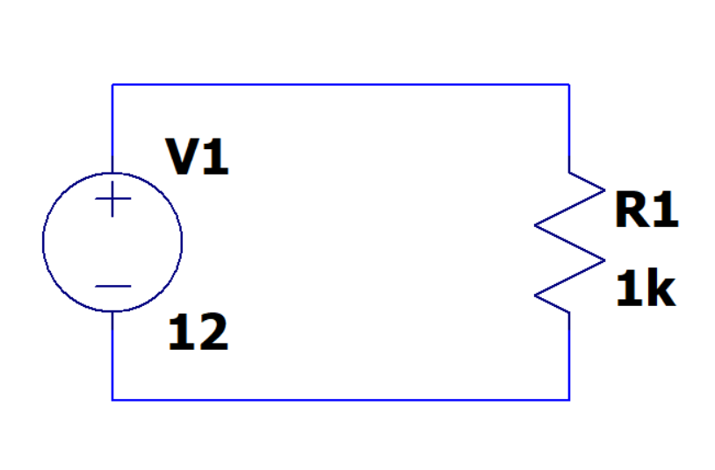
Fig.1. Example circuit in Ltspice
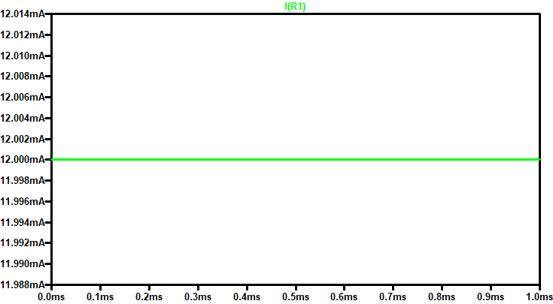
Fig.2. Results example

$U=R∙I$ (1)
from this
$I=\frac{U}{R}$ (2)
Table of measured results:
Table 1. Results example
R | I
1kΩ | 12mA
2kΩ | 6mA

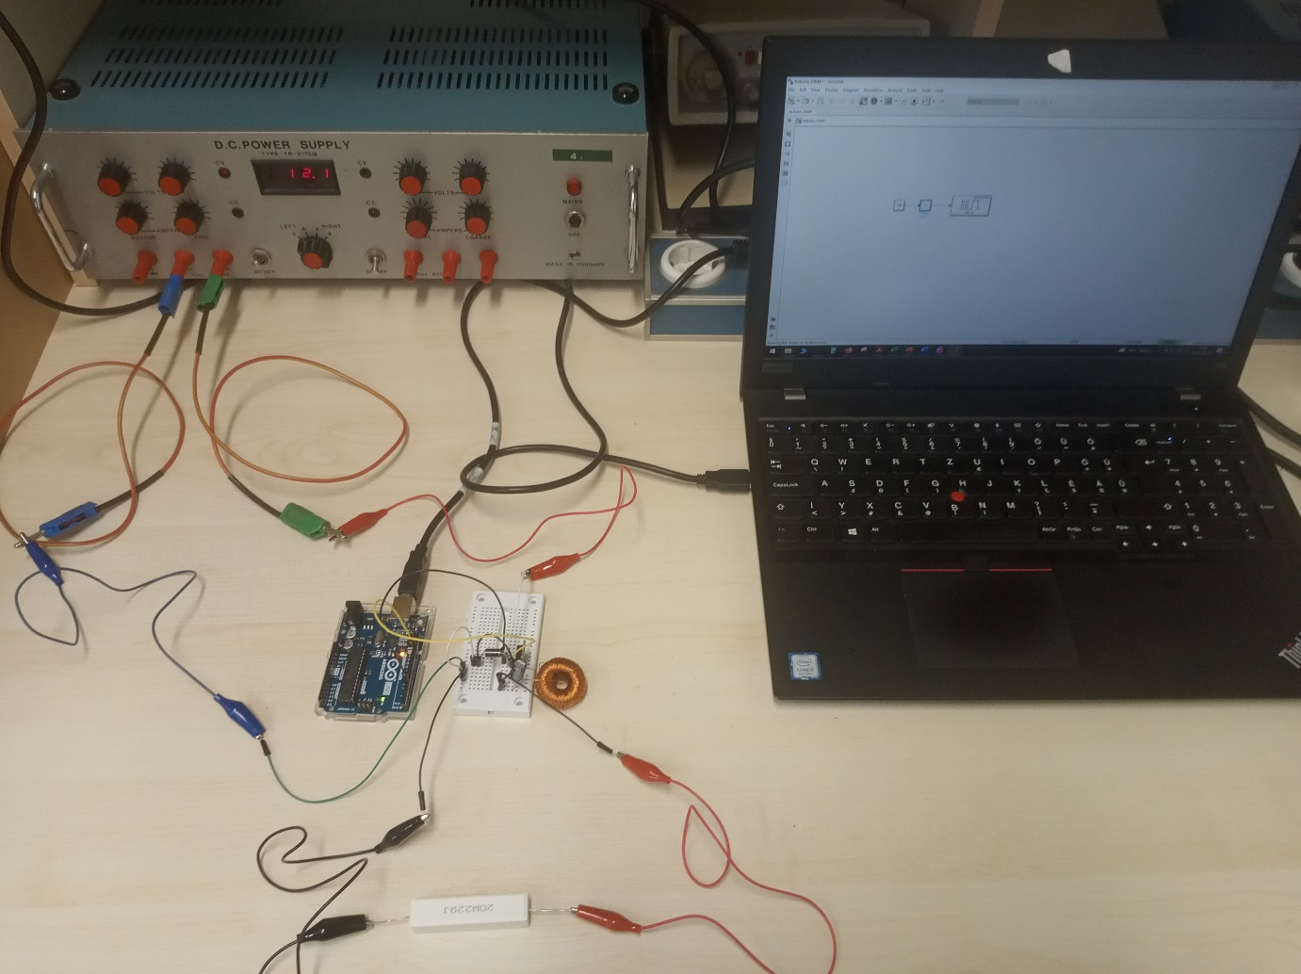
Fig.3. Foto example

3. Conclusions
In this document we have learned how to document the measurement.

